Hackathon Project 2026: Abstract Submission
Group: Hurrain Ghaffar, Irene Kellegher, Izabela Heczkova
Team/Project Name: Rubus Labs
Duration: 12 weeks
Theme: IoT is Bold
Description of project:
Environmental Monitoring & Surveillance: Monitor temperature, humidity, pressure. Capture photos when conditions change. Create time-lapse sequences. Detect disturbances with accelerometer.

Raspberry Pi Hardware Kit
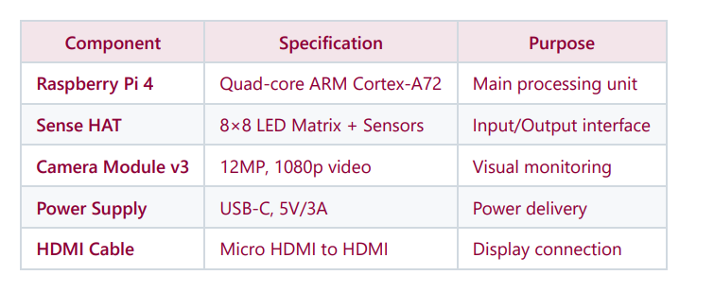
Hardware Needed: Raspberry Pi & Sense Hat, Install Raspberry Pi through Raspberry Pi Imager
Sense-Hat: We will use Sense Hat to measure temperature, develop thresholds and display soil state (cold, moderate, warm) using its LED light with Python.
How To Use Python With Sense Hat -https://projects.raspberrypi.org/en/projects/getting-started-with-the-sense-hat/3

GitHub Repository: Hackathon_Project_2026
https://github.com/Hurrz7789/Hackathon_Project_2026

Brainstorming Ideas:
- Environmental - LED Plant Monitor Sensor - Using Sense Hat with Raspberry Pi to create an embedded system which monitors temperature and humidity of soil. The embedded system’s aim is to check whether the soil is too wet or dry, hence displaying warning signs on Sense Hat to alert users of the soil condition
- Baby alarm - Using a Micro bit, Flask, Python to develop a sound alarm system used for baby monitoring. An alert sound is played on the micro bit to alert the user that the baby has woken up.

Roles : TBA
Hurrain -
Irene -
Izabela -

Environment Data: Soil Conditions & Plant Growth
Using Python we will perform data analysis to create thresholds for soil temperature, indicating the current state of soil using LED sensors and whether it is wet, dry, or at optimum state. Below is key information about the threshold for soil temperature.

- Wet/Waterlogged Soil (Low SMD): Generally defined by SMDs near zero or negative (e.g., -10mm for moderate/poorly drained soils), which often occurs when soil temperatures are below 5°C-6°C in winter/early spring.
- Dry Soil (High SMD): An SMD above 30mm indicates a restriction to growth on free-draining soils. SMDs in excess of 75mm indicate drought conditions. Temperature ranges from 35°C to 40°C.
- Optimum Growth Temperature: Soil temperatures generally 10-15°C are critical for spring growth and grass growth.

Temperature Thresholds:
Temperature | State | Colour | State
Below 5 - 6°C | Wet/waterlogged | Blue | Cold
10 - 15°C | Optimum growth | Green | Moderate
35° - 40°C | Dry soil | Red | Warm/too dry

